# Coax to waveguide transition.

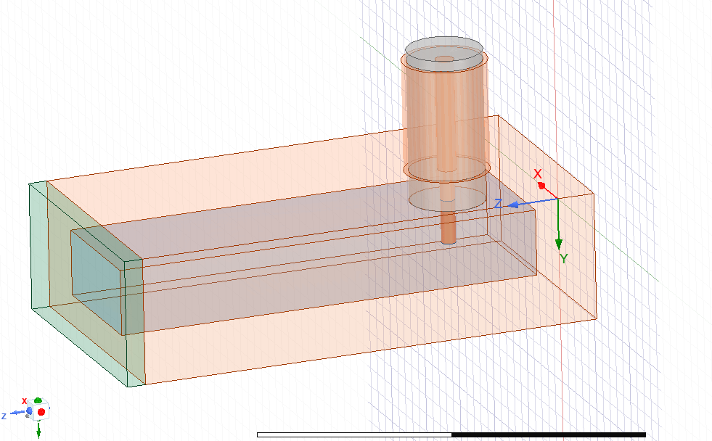

The below figure is with only one mode selected on the waveports. In other words, all modes that can propagate are added into this (I’m assuming).

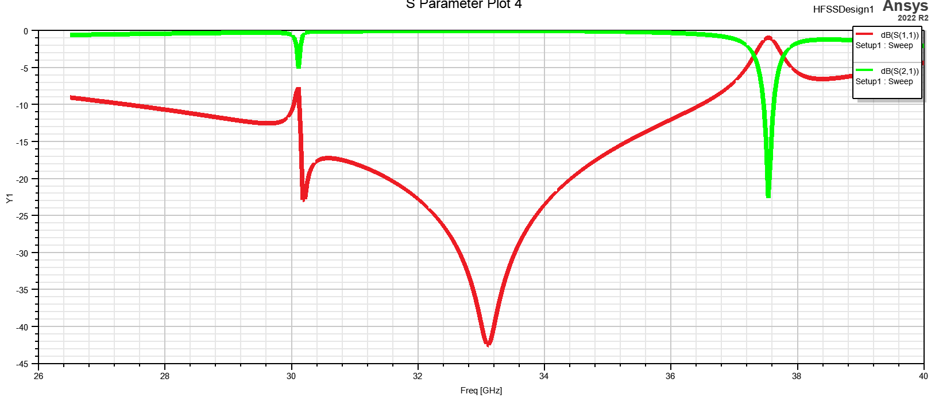

My initial suspicion is on the coax cable, allowing TE11 to propagate. See further for justification.

The below figure is with 3 modes selected on the waveports. However, this is only a plot of S1,1:1,1 and S2,1:1,1. Port 1, mode 1 and port 2, mode 1.

Below is the representation of the first 3 rectangular waveguide modes.

First being TE10

Below are the first 3 coax cable modes:

First being TEM, second being TE11 that I’m concerned with?

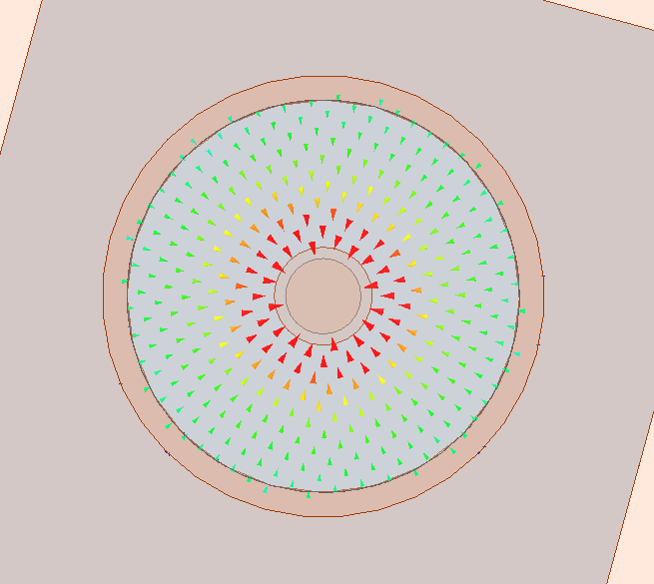

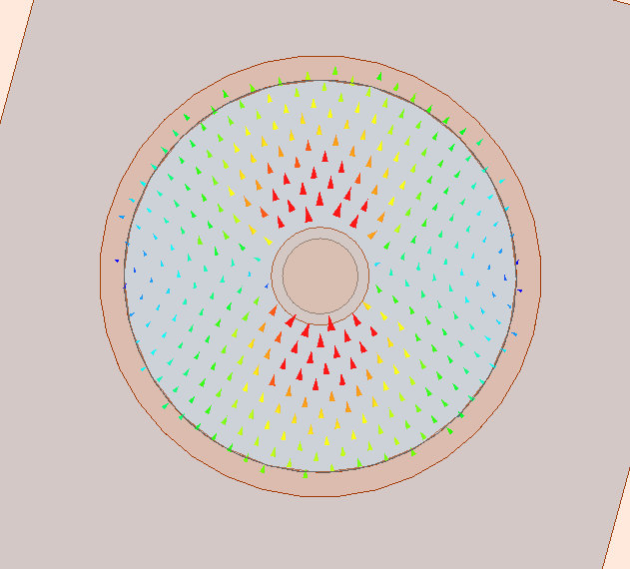

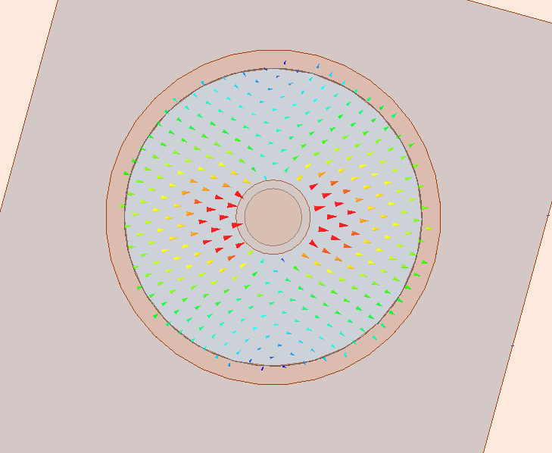

Below is the plot of the S-params of these modes.

See plot of S21. Here we can see that on port 2, mode 2 and port 1 mode 1 has a low enough return loss to propagate. S2:2,1:1. See green trace.

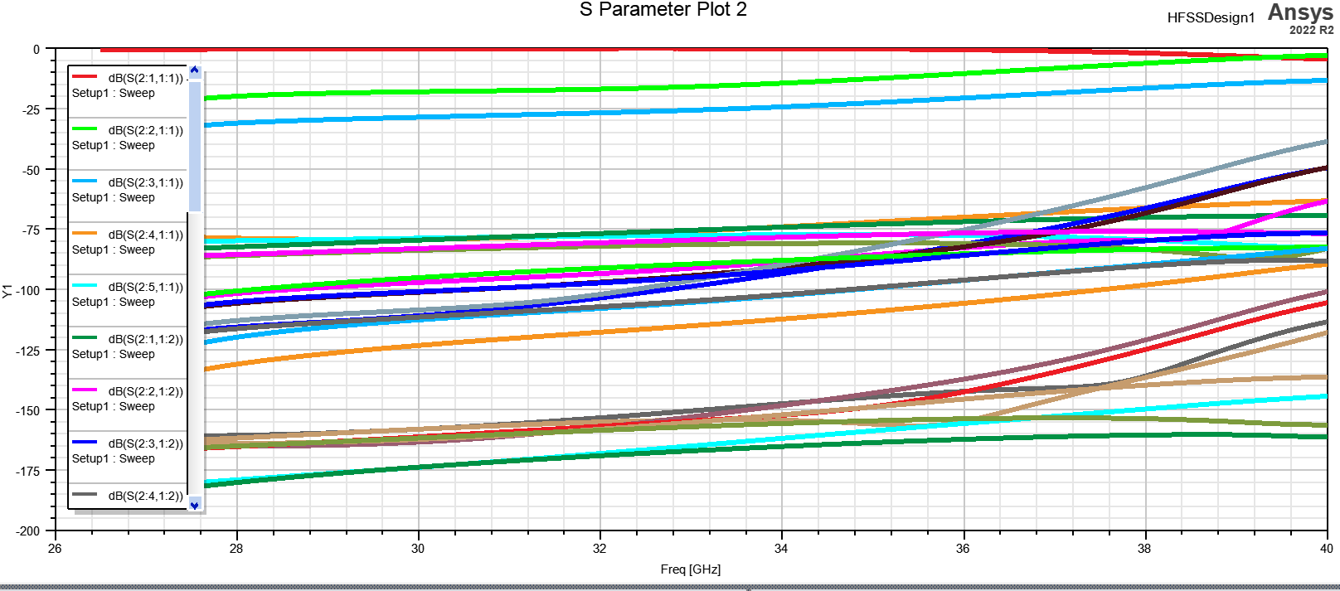

S11 is not really useful here.

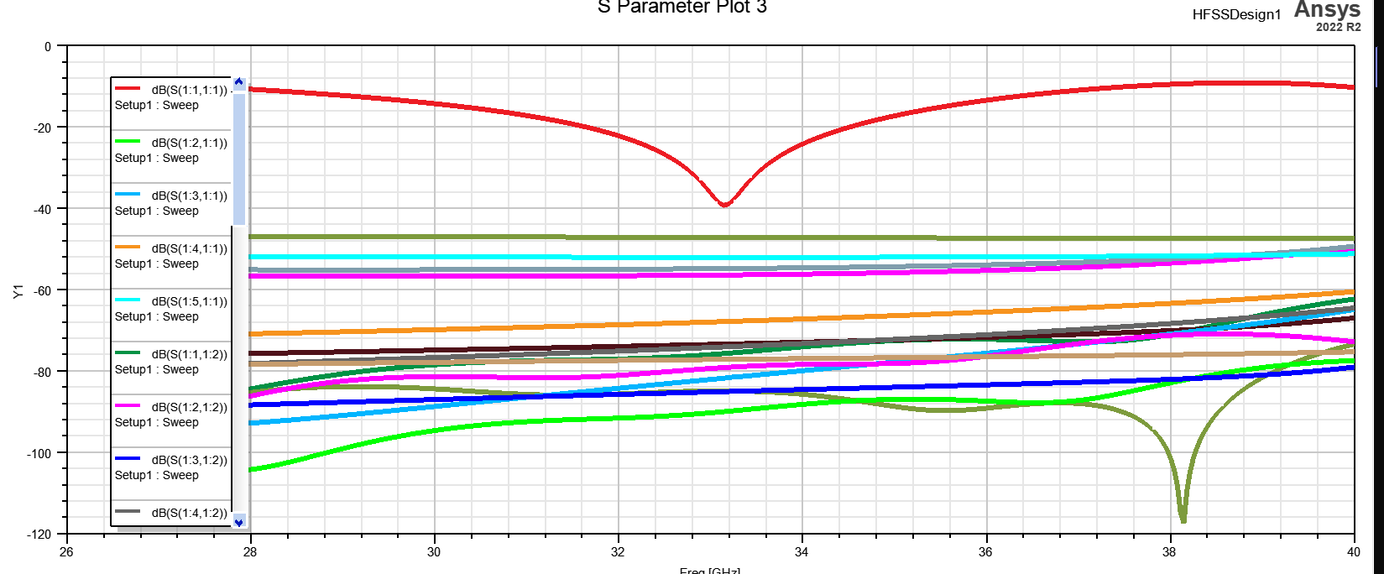

This makes sense that TE11 will propagate at the higher end of ka-band, whilst using 3.5mm connector species.  
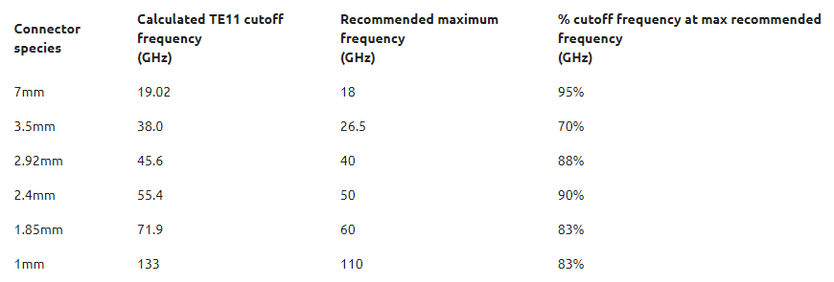

I have not yet tested this hypothesis, but it could be simulated with little effort.

## Solution

If this is the root cause, I could change over to a 2.92mm connector species, or design a microstrip feed.